# Nosema Disease of Honeybees

**Khalil Hamdan Apeldoorn**

**The Netherlands**

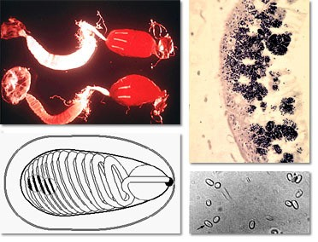

Photo credit :**[www.tbuskruid.be/.../bijen/bijenziekten.asp](http://www.tbuskruid.be/.../bijen/bijenziekten.asp)**

Nosema is a disease of the digestive tract in honeybees. It effects adult bees only and is highly infectious. The disease occurs primarily in late winter and early spring. Nosema is troublesome in temperate areas and especially in long periods of bad weather where bees are confined to the hive and are unable to leave on cleansing flights thereby more spores accumulate in the rectum. The disease is less readily spread in warm climates with mild winters. Nosema has negative effects on the bee colony. It increases the mortality of adult bees and the death of some colonies during winter, reduces honey yields, further causing poor population build up because the bees are unable to produce enough royal jelly to feed the brood. If a queen becomes infected, her ovaries degenerate and her egg laying capacity is reduced due to atrophy of the eggs. The severity of infection varies among colonies. In slight infection, losses are small, but in severe infection the colony will dwindle and ultimately die out.

Nosema can be serious if not checked and the beekeeper should have an understanding of the nature and spread of the disease and the measures for the control of the disease.

# Cause

Nosema disease is caused by the microscopic *Nosema apis* and *Nosema ceranae*, spore-forming parasites, which attack the lining of the middle intestine of the worker bees, queens, and drones. It lives in the intestine of a bee until it is voided in the feces. The female lays 8-20 eggs, and the parasite completes its life cycle in about 9-12 days.

# Biology

The nosema spores enter the adult bee through the mouth. When they reach the mid-gut (between the honey stomach and the small intestine) they live as parasites in the epithelial cells that line the interior of the mid-gut whose function is to produce the digestive enzymes, which enable the bee to digest the pollen in its diet. Here they develop, multiply rapidly and produce more spores. The parasites utilize the contents of these cells as a food supply and as a result, reducing the efficiency of the gut in the digestion and absorption of food, and weakening the bee. The cell then bursts and releases the new spores into the mid-gut, which repeats the cycle process inside the mid-gut, and some pass through the small intestine to the rectum and accumulate there. A heavily infested

worker bee can contain 30-50 million spores. The spores are voided in the bee’s excrement and these foil the top bars of the frames, the combs, and the honey as well as on the walls of the hive. The spores remain latent over a year in dried spots of excreta on combs and for 3-4 months in honey.

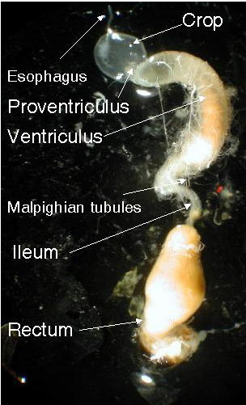

**Honeybee digestive tract**

Photo by Zachary Haung

1. Within the hive:

# Transmission and Infection

Defecation by diseased bees inside the hive is the prime source of infection. When healthy worker bees clean the hive they become infected with spores by ingesting fecal matter or contaminated food.

1. Between hives:

The spread of nosema disease from hive to hive occurs by transferring contaminated combs between hives, feeding bees with honey contaminated with spores, and by splitting and uniting contaminated hives. Furthermore, robbing of honey from infected hives, drifting, infected package bees, and an infected queen and her attendant workers are factors of transmission.

The occurrence of nosema disease varies during the year. In the spring the level of infection increases rapidly as brood rearing starts and flights of bees are restricted by unsuitable weather and bees are actively cleaning contamination from the combs. In late spring infection declines gradually as infected bees are now able to fly and defecate outside. Also, the old bees die off and are replaced by newly emerged bees, which are free of infection. During summer the infection disappears as combs become cleaner. However, some infection can remain within a colony in summer and reappears in the next spring in untreated colonies.

# Symptoms

Defecation inside the hive. Yellow or yellowish brown excrement stains are noticed on top bars of frames, combs, bottom board, and on the inside and outside walls of hive.

Bees infected with nosema often show signs of from dysentery.

A colony failing to build up population in ideal condition in spring could indicate nosema disease.

Poor attention to brood rearing.

Sick bees with distended abdomens crawl about in front of the hive with their wings spread out.

Bees are unable to fly or can fly only short distances when they leave the hive.

A heap of dead bees on the ground in front of the hive in spring.

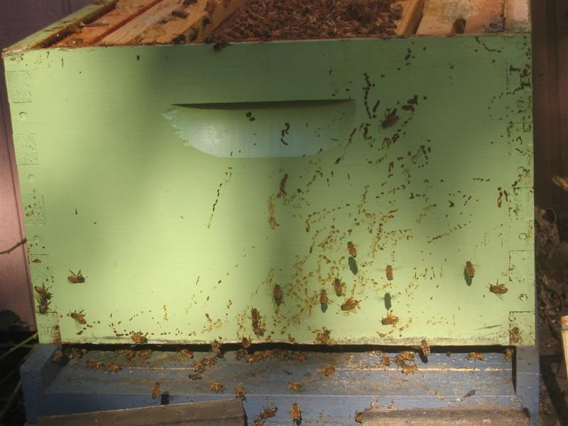

**Yellowish brown, watery splashes on the wall of the hive.**

Photo credit: Hive-mind.com

**Dry spots of excreta on soiled combs.**

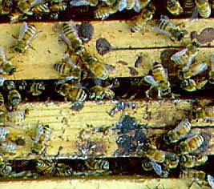

Photo by Ingemar Fries

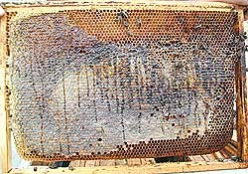

**Symptoms of dysentery on a comb caused by nosema**.

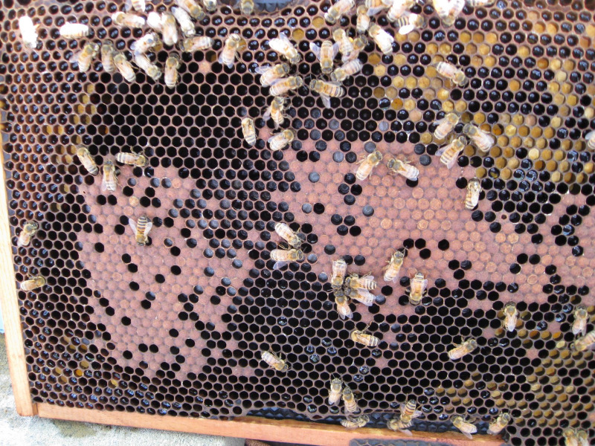

Photo credit: Czasopism “Pasiek”

[www.pasieka.pszczoly.pl](http://www.pasieka.pszczoly.pl/)

**A colony infected with nosema. The frame showing a small number of adult bees for the size of the brood nest.**

Photo credit: beekeeperlinda

# Diagnosis

Nosema disease can be detected by the Nosema Field Test, and with the aid of a microscope, which will provide a definite diagnosis.

Diagnosis can be done in late winter or in early spring. Collect 10-25 bees from the hive entrance. It is of importance that the bees collected for diagnosis are old bees (over 15 days old). Older bees are susceptible to infection, and newly emerged bees or bees less than 15 days old are less infected with the disease. Live bees are preferable, however, dead bees can be collected and examined for spores.

Nosema Field Test

Nosema can be identified in the apiary without a microscope with so- called Nosema Field Test by dissecting out the midgut of adult bee and examining it for the general appearance of it.

Procedure:

Select a crawling bee or an adult bee from the hive or entrance Hold the bee by the thorax between thumb and forefinger Remove the head of the bee with tweezers or forceps

Pull the sting and last segment with tweezers out of the abdomen.

Keep pulling until the hindgut, midgut and the honey stomach have emerged

Place the whole digestive system over a sheet of white paper Take a close look at the midgut. A healthy midgut is normally

brownish yellow in colour and has a ringed appearance. A midgut infected with nosema, on the other hand, is white, swollen and without rings or constrictions.

Alternatively, collect 10 to 25 bees per hive and place the sample in the freezer to kill bees. Thaw and remove the midgut as explained in the process above.

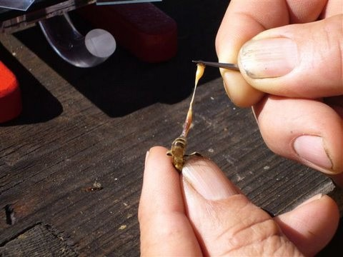

**Nosema Field Test. Dissecting out the midgut of adult bee.**

Photo credit: Randy Oliver**,** [www.scientificbeekeeping.com](http://www.scientificbeekeeping.com/)

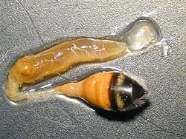

**A healthy midgut is brownish yellow in colour**.

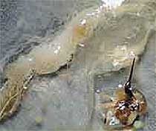

Photo credit: Czasopism “Pasiek”,

[www.pasieka.pszczoly.pl](http://www.pasieka.pszczoly.pl/)

**Nosema infected midgut is white in colour due to the accumulation of spores**

Photo credit: Czasopism “Pasiek”,

[www.pasieka.pszczoly.pl](http://www.pasieka.pszczoly.pl/)

Microscopic Examination

A positive diagnosis can be made microscopically by examining the midgut content of sick bees or their excretion for the presence of spores.

Equipment required:

A compound microscope having a magnification of 400 diameters Microscope slides

Cover slips or glasses

A small porcelain mortar and pestle

The standard method is to kill the collected bees either by placing them in freezer or in a bottle into which an absorbent paper soaked with ethyl acetate is added, or live bees are soaked in alcohol for at least 5 minutes and the alcohol is drained off. Remove the bee’s heads and use only the abdomens. Place in mortar with 1 ml water for every bee. Crush with pestle until mixture is uniform, or the bees can be placed in a plastic bag and crushed, using a rolling pin.

A droplet of the suspension is then placed on a slide and covered with glass and examined for spores under a magnification of 400 diameters. Nosema spores are rice grain shaped and uniform.

Another diagnostic technique of preparing a smear is to pull out the gut from the abdomen of a bee and place the midgut on a glass slide and cover with a cover slip and squash with the finger.

Examining fecal material:

Scrap off a dry spot of excreta on a soiled comb or on the hive wall and

place on glass plate. Mix with drops of water to prepare a wet suspension and transfer a drop of the suspension to a microscope slide. Place a cover glass over the feces and view under the microscope for the presence of spores.

Taking a sample of a suspected queen:

To verify the presence or absence of nosema in a queen, confine her alone in a vial or in Petri dish. The queen will defecate within an hour. The queen’s excreta look as drops of colourless liquid. Transfer this liquid to a microscopic slide and place a cover glass over the liquid, and examine under the microscope for the presence of spores under a magnification of x 4000.

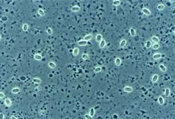

**Nosema spores under the microscope.**

Photo: Experimental Ecology ETH Zurich

# Recommendations for preventing Nosema from spreading

The application of preventive and prophylactic measures helps prevent the development and spread of nosema. These measures are as important as the treatment.

Place hives at sunny sites and avoid damp places and wet areas. Overwinter only hives with a large population of young bees.

Avoid conditions of excess moisture inside the hive during the winter. Ensure adequate stores of honey and pollen in hives for winter.

Do not unite diseased hives with healthy ones.

To reduce nosema transmission, do not transfer contaminated combs between hives.

Contaminated combs with nosema spores should be sterilized by

fumigation with concentrated 80 percent acetic acid.

Nosema is transmitted when healthy bees clean contaminated combs.

To eliminate the infection, transfer infected colonies to clean combs and hives early in the season, and stimulate infected colonies to produce young bees, as emerging bees are free from infection. Infection will disappear as the old bees die.

Disinfect hive bodies, bottom boards and inner covers before using by

fumigation or scorching with blowtorch.

In a severe infection, destroy the colony by burning the bees and the inner equipment and disinfect the hive thoroughly.

A very effective treatment is the use of Fumidil-B in combination with a complete change of combs.

To reduce the level of spores within the hive, remove continually old,

dark brood combs on which the bees wintered, and replace with clean ones.

# Treatment and Control

Treat with the antibiotic Fumagilin (Fumidil-B) once in autumn and once in early spring as a preventive measure and for control of nosema. Feeing Fumidil-B in sugar syrup to overwintering bees can reduce the incidence of nosema infection during the following spring. Mix Fumidil with sugar syrup (2 parts sugar to 1 part water) and feed the medication in the formulation of 1**½** level teaspoons (75-100 mg) of Fumidil in 4**½** litres of sugar syrup for each colony. The medicated syrup is given in upturned jars with pinholes pierced in the tops. The antibiotic Fumidil-B kills the active stages of nosema, but not the spores.

Tip: Always follow label directions when medicating beehives.

Note for Beekeepers in the UK.

Fumagilin (Fumidil-B) is now banned in the UK and is no longer available. If you are caught using it you can be in trouble. All this is thanks to our mates in the EEC who think they know it all, when in fact they know very little.

# Disinfection of Combs

Spores of nosema can survive more than one year on the combs. If you do not disinfect combs, the spores spread in other hives and infect the colonies. Combs from infected colonies can be disinfected for reuse by fumigation with 60-80% acetic acid vapour. The acid vapours kill the nosema spores within a week. It is also effective in killing European foulbrood organisms. The 80% acetic adding 1 produces acid part water to 4 parts of glacial acetic acid (water-free acetic acid). It is recommended to proceed at a temperature higher than 15 degrees C for faster evaporation.

Method:

Put the combs to be sterilized into empty boxes.

Place a box of combs on upturned outer cover of a hive.

Place a wad of cotton wool 15x15 cm or an absorbent pad soaked with

**½** cup (125 ml) of 60-80% acetic acid over the frames.

Pile up boxes above the first one as high as needed, placing a soaked wad over the frames between each box.

Seal between each box in the stack and any cracks or holes with

adhesive tape to prevent the vapour from escaping.

Cover the top of the stack with the hive roof and leave for one week to fumigate.

After fumigation, air the combs for a few days before reusing.

A simple way to fumigate combs is to stack five boxes with combs on upturned cover of a hive. After stacking up the boxes, seal the joints between the boxes with a tape to seal in the vapour. Place anon-metallic tray e.g. a saucer containing acetic acid on the top box, using approximately 600 ml 60-80% acetic acid per stack of five boxes. Add an empty box on the top of the stack, and then cover the stack with a hive cover or plastic and leave for a week to evaporate. The vapours of acetic acid are heavier than the air and will travel from the top to the bottom of the stack.

Tip: Wear gloves, goggles and avoid the fume, and wash off splashes on the hand with water without delay.

Wintering bees on disinfected combs is advisable with or without medication. Strong contaminated colonies must be transferred to disinfected or clean combs and must be treated in spring. Contaminated honey can be disinfected by heating it to 60ºC for 30 minutes.